Access Review & Audit Readiness Report

1. Introduction
Access reviews ensure that user permissions remain appropriate over time and align with job responsibilities. They are critical for maintaining compliance and reducing security risks.

2. Objective
- Review user access and permissions
- Identify excessive or unused access
- Remediate inappropriate access
- Prepare audit-ready documentation

3. Tools Used
- Microsoft Entra ID
- Azure Portal
- CSV Export

4. Access Review Process

Step 1: User and Role Data Collection
User data was exported from Entra ID and reviewed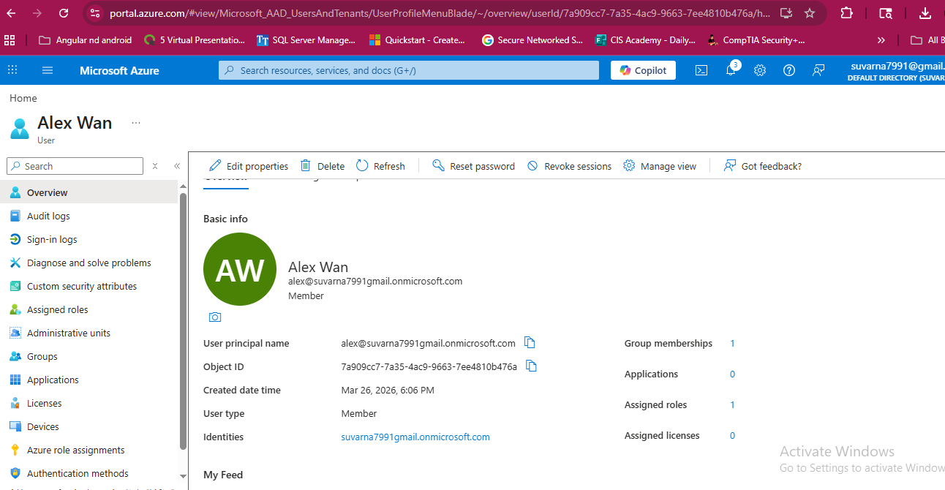

Step 2: Access Analysis
User roles were compared against expected responsibilities.
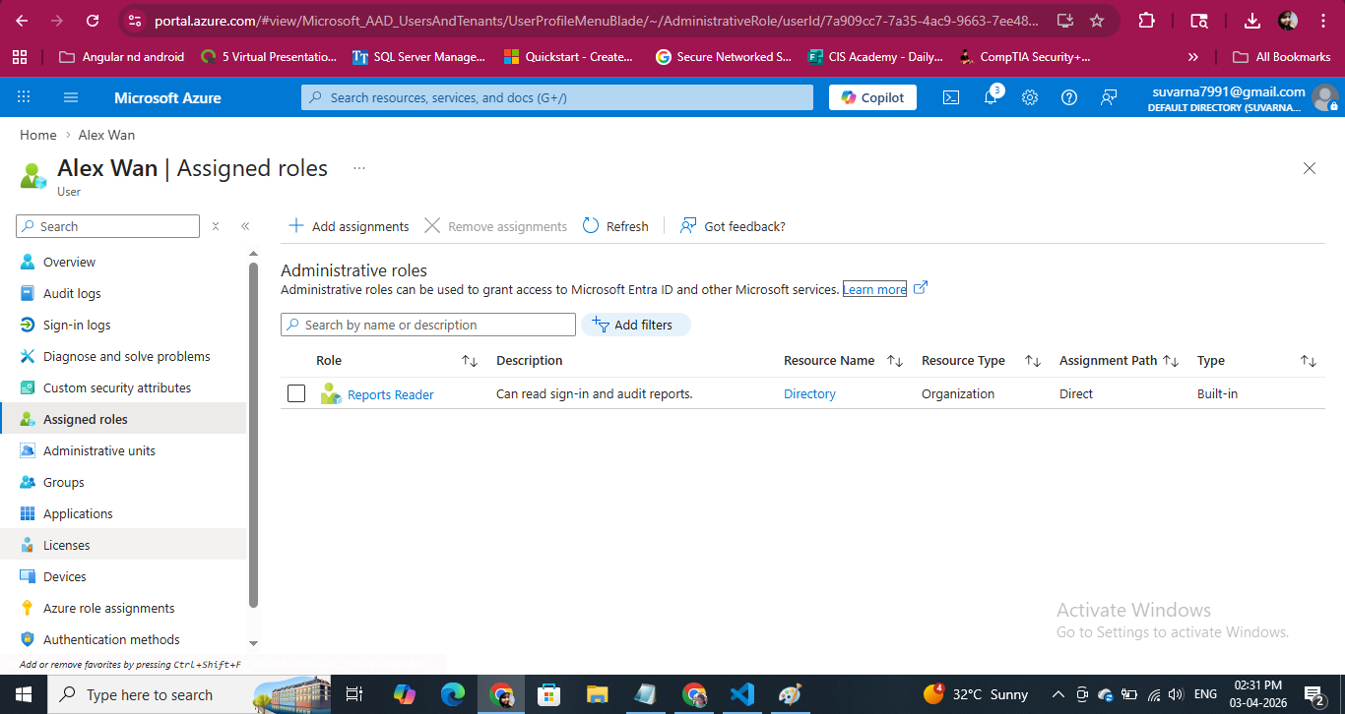

Step 3: Identify Issues
Example issue identified:
- Unnecessary role assigned OR unused account
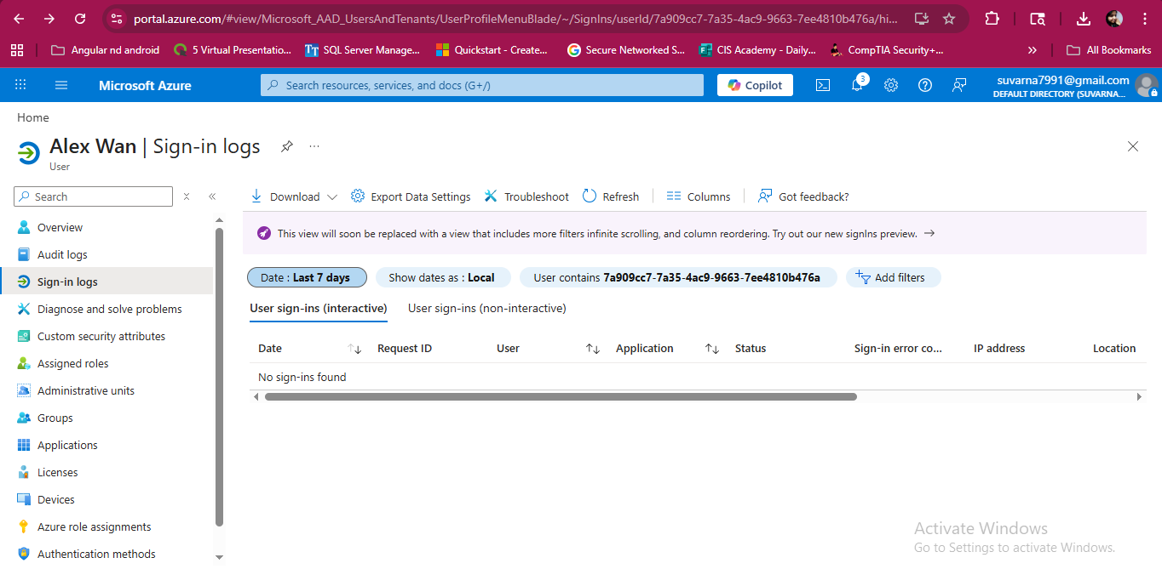
Step 4: Remediation
Access was corrected by removing unnecessary roles or disabling accounts.
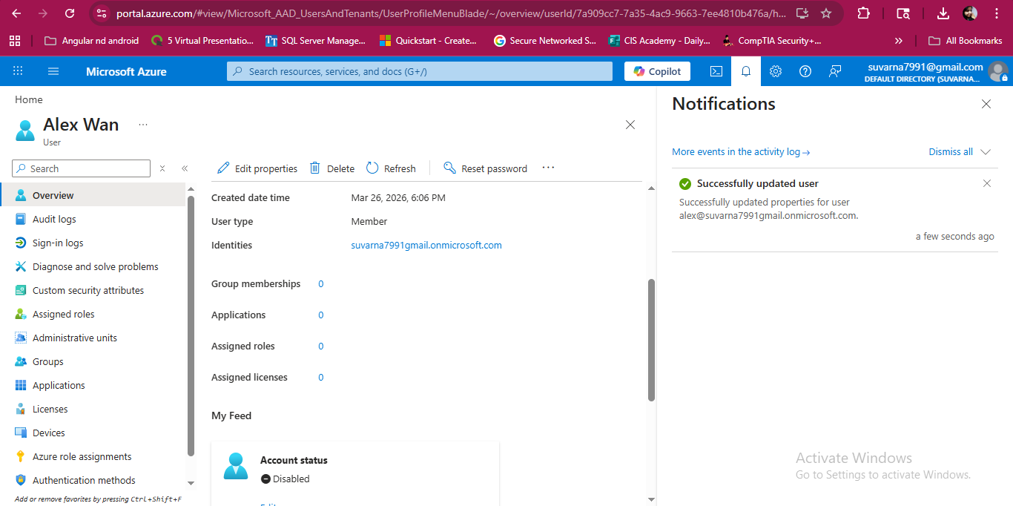

Step 5: Audit Validation
Changes were verified using audit logs.
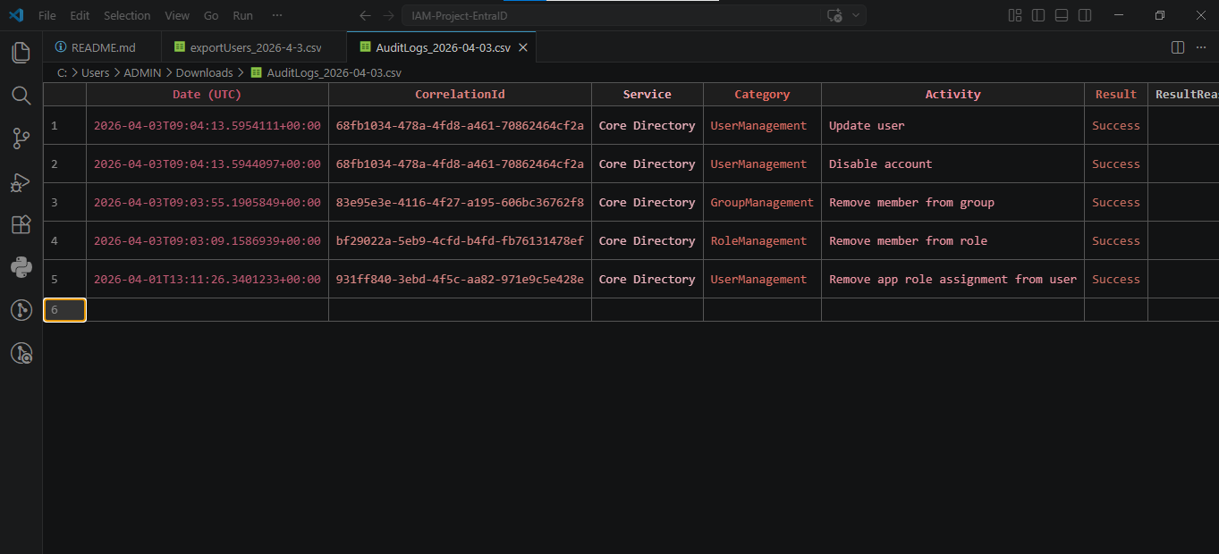

5. Security Controls Applied
- Least privilege enforcement
- Periodic access review
- Role validation
- Audit logging

6. Key Learnings
- Importance of periodic access reviews
- Identifying excessive permissions
- Maintaining compliance readiness
- Documenting IAM processes for audits

7. Industry Relevance
Access reviews are mandatory in regulated environments such as banking, healthcare, and government sectors.
This aligns with IAM responsibilities in Canadian organizations.

8. Conclusion
The access review successfully identified and remediated inappropriate access while generating audit-ready evidence, demonstrating effective IAM governance practices.

